### CLOUD COMPUTING

NAME: Kaustubh Mahamuni

### ROLL NO: TCOB53

CLASS: TE COMPUTER B Div

### BATCH: B3

TITLE: MINI PROJECT REPORT ON

PRODUCT MANAGEMENT SYSTEM

**Index**

1. Introduction to Cloud Computing 3

1.1 Service Models of Cloud Computing 4

2. Salesforce 6

2.1 Introduction to Salesforce 6

2.2 Architecture of Salesforce 6

2.3 Salesforce Multiple View Controller (MVC) 7

2.4 Technologies of Salesforce 8

3. Product Management System 9

3.1 Introduction 9

3.2 Technology and Use 10

**4. Results .................................................................................................... 11**

# 1.Introduction to Cloud Computing

Cloud computing is usually defined as storing and managing the data over the cloud, rather than a local server. Cloud computing is easy to understand. All applications are developed and run in the web browser. Using the internet connection, users and developers will have access to whole applications thus eliminating the complexity and overhead of the maintain environment.

Unlike traditional business applications which are complicated, expensive and need experts to install, run, update and secure, cloud computing can be accessed anywhere with an online connection. In traditional systems, the entire infrastructure must work together. For such type of seamless interaction, and for the smooth run of the system, a constant maintenance is always required. With cloud computing, there is no necessity to invest money in acquiring and supporting hardware and software infrastructure, thus decreasing the potential cost for users and developers.

The main impact of cloud computing is on the responsiveness of IT systems. With the cloud computing environment, we can add users and developers instantly, and the applications can be deployed rapidly into the cloud which reduces the user request response time. As the complexity of the of the internal systems is removed, the organization can speed up the entire IT process.

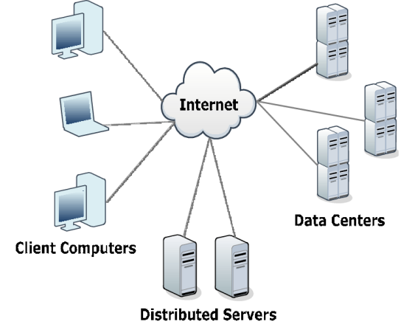

## 1.1 Service Models of Cloud Computing:

**1.11 Software as a Service (SaaS):**

The end user can access the application which is developed by the provider on a cloud framework. The developed applications are available from different customer devices through interfaces like a web program or a program interface. Cloud infrastructure, servers, networks, storage and operating systems cannot be managed or controlled by the customer [9,12]. Cloud application services represent the increasing cloud market. Software as a service utilizes the internet to deploy the applications overseen by the vendor and whose interface will be able to access on the customer side. Many of the applications developed using SaaS will run in a web browser by using some plugins. There will not be need of any download or establishments. The major applications which are developed using SaaS are healthcare related applications, client relationship administrations, incorporate email, and collaboration. Some of the costly ventures which are not able to considered as software vendors started using SaaS to get the upper hand and gain income.

**1.12 Platform as a Service(PaaS):**

The Client can deploy onto the cloud infrastructure developed by the customers with the help of libraries, tools, services and the programming languages which are supported by the client. The underlying infrastructure of cloud and storage, servers, network or operating systems cannot be managed or controlled by the Customer [9]. Cloud platform services can be utilized for applications and their advancements when cloud segments are given to programming. Developers can be able to pick the structure using PaaS where the applications can be expanded to create or modify. The testing and deployment of applications become easy and fast if the PaaS is used. Enterprise PaaS gives a self-service portal to programming engineers for overseeing computing infrastructure from information technology operations. Scalability, Software as a service enablement and multi-occupancy can be acquired by the applications using PaaS. The coding fundamental measure will be decreased for the enterprises using PaaS and the application will be converted to a hybrid model.

**1.13 Infrastructure as a Service (IaaS):**

The customer can arrange systems, storage, processing and other essential computing resources in which the client can run and send arbitrary software like applications and operating systems. The hidden cloud infrastructure is not controlled or overseen by the customer but rather he can control over operating systems, storage, servers and network. Cloud infrastructure services, referred to as IaaS, are models beneficial for overseeing and observing remote data center frameworks such as organizing, processing, stockpiling and networking services. With the help of IaaS, clients will get utility billing and power benefits.

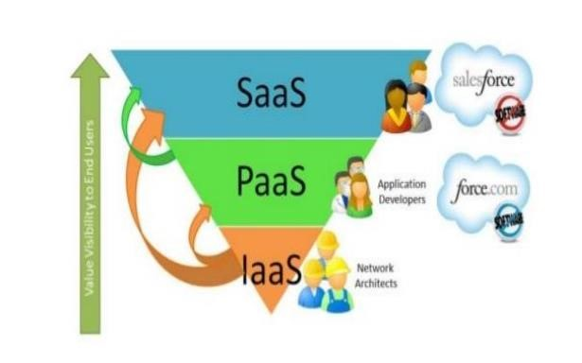

# 2.Salesforce

## 2.1 Introduction to Salesforce:

Salesforce is one of the world's prime cloud computing companies and number one on-demand customer relationship management(CRM). Salesforce does not need any software installation or hardware or any infrastructure like servers. All we need to access Salesforce is the internet. This empowers even the most non-techie individuals to be able to use the system and configure it as per their needs. Established as Salesforce.com(SFDC) and its customer relationship management (CRM) service and then divided into different sectors like sales cloud, service cloud, community cloud, analytics cloud, data cloud, marketing cloud, app cloud, and so on. Since Salesforce coordinates well with all the platforms and supports all major OS and mobile devices, it is anything but difficult to utilize Salesforce outside of the workplace, thus helps to improve productivity.

## 2.2 The Architecture of Salesforce:

Salesforce has a multi-tenant Architecture. Multi-tenancy is the fundamental technology utilized as a part of the cloud to share its resources safely and cost effectively. It's much the same as bank services where various tenants costefficiently share a common infrastructure yet safely and with most protection from other tenants. A cloud utilizes multi-tenant infrastructure to share its assets safely among different applications and occupants (organizations, associations, and so on) that use the cloud. Some clouds utilize virtualization-based architecture to confine occupants; others utilize custom software architecture to take care of business. The multi-tenant outline of a cloud service can dramatically affect the application delivery and the profitability of IT organization.

## 2.3 Salesforce Multiple View Controller (MVC):

MVC is a design pattern which separates business logic from interface logic i.e. it separates the graphical interface displayed to the user with the code that manages the user actions [4]. In Salesforce, using SFDC visual force, we can write VIEW pages which are very similar to java servlets page(JSP) pages. Each visualforce(VF) page is corelated with a controller. The controller and model classes can be written using Apex language. In SFDC, controller part comprises of workflows, triggers, Apex classes and model layer comprises of fields, relationships, objects and View layer comprises of Tabs, page layouts, VF pages. SFDC MVC mainly consists of three modules namely Model, View and

Controller. 1) Model: Here we represent what schema and data the Salesforce used for the system representation and Sobjects are a model, as every entity is mapped to some subject in Salesforce. 2) View: Here we represent how data and schema and visual force are used to present data to users. 3) Controller: Here we use controllers and interface actions to perform actions when the user interacts with visual force.

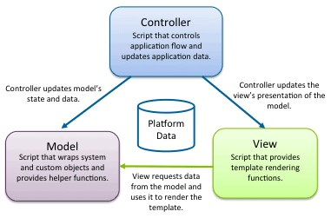

## 2.4 Technologies of Salesforce:

1. Apex Salesforce has a programming language called Apex. It is a caseinsensitive, mostly typed object-oriented programming language with syntax identical Java with curly brackets and dotnotation syntax. Apex is used to run programs and procedure in Force.com such as links, buttons, record insertion and so on with visual force custom controllers.

1. Visualforce Visualforce(VF) is a framework for the Force.com platform with tag-based markup language identical to HTML. With the help of Visualforce, custom pages can be created for mobile apps and desktops with the help of with other front-end technologies like HTML, CSS, jquery, and JavaScript. With the Visualforce standard and custom controller features, we can build our own business logic in Apex.

1. Lighting Lightning is a component-based framework for the Salesforce1 mobile app which is built on an open source Aura framework. With the lighting framework, responsive applications can be built easily. The apps build on the Lighting framework is sold or brought on AppExchange [5]. Lightning App builder for Salesforce is a tool for quick application advancement of responsive web interfaces. This interface takes into account distinctive screens to be assembled given lightning segments. This can be layouts as formats for records or particular applications.

# 3.Product Management System:

## 3.1 Introduction:

Product management is the process of managing all the information required to market and sell products through distribution channels. This product data is created by an internal organization to support a multichannel marketing strategy.

A central hub of product data can be used to distribute information to sales channels such as e-commerce websites, print catalogues, marketplaces such as Amazon and Google Shopping, social media platforms like Instagram and electronic data feeds to trading partners.

PIM solutions are most relevant to business-to-consumer (B2C) and businessto-business (B2B) firms that sell products through a variety of sales channels in a range of industries. The use of PIM is generally influenced by a company's:

* wide array of products and/or complex product data set
* frequently changing product characteristics
* increasing number of sales channels
* non-uniform IT infrastructure (plethora of data sources and formats)
* online business and electronic ordering
* various locales and localization requirements

This systems manage customer-facing product data needed to support multiple geographic locations, multilingual data, and maintenance and modification of product information within a centralized catalogue. Product information kept by a business can be scattered throughout departments and held by employees or systems, instead of being available centrally; data may be saved in various formats, or only be available in hard copy form. Information may be needed for detailed product descriptions with prices, or calculating freight costs. It represents a solution for centralized, mediaindependent product data maintenance, as well as efficient data collection, enrichment, data governance and output.

## 3.2 Technology and Use:

This systems consolidate all product information onto a single platform. It helps connect retailing and manufacturing channels to counter complex challenges in managing and maintaining product data quality. In terms of company [IT infrastructure,](https://en.wikipedia.org/wiki/IT_infrastructure) this means having a PIM platform running over or alongside a database with an application server, and/or [XML-](https://en.wikipedia.org/wiki/XML)based exchange of product information. This forms a foundation upon which to build sales and procurement business processes. With this solutions, access and user authorizations for all database information, ordering processes linked with [inventory management systems](https://en.wikipedia.org/wiki/Inventory_management_software) and the mechanisms for modular expansions are managed via a web-based administration interface.

[Point of sales](https://en.wikipedia.org/wiki/Point_of_sale) systems and [online shopping](https://en.wikipedia.org/wiki/Online_shopping) platforms such as online marketplaces are based upon electronic catalogues. This systems can load descriptive product information as content into a catalogue management solution, where products are grouped and managed for specific target markets. Data exchange interface standards such as [Open ICEcat](https://en.wikipedia.org/wiki/Open_ICEcat) allow seamless interchange of electronic catalogues between vendors on the one hand and purchasing firms and marketplace operators. [Eprocurement](https://en.wikipedia.org/wiki/E-procurement) solutions are closely related, which automate the procurement process for purchasing goods and services. These create transparency for the product data of multiple vendors to support the centralized management of multi-supplier catalogues and facilitate price and quality research.

Data management systems are often not interoperable meaning that data exchange without this can lead to severe repercussions for a business. Some companies use [master data management](https://en.wikipedia.org/wiki/Master_data_management) as an IT resource in lieu of PIM. But MDM systems are not a business application and often lack usability, product data management capability including data enrichment, validation and workflow rules, which impact [return on investment.](https://en.wikipedia.org/wiki/Return_on_investment)

IDC, a technology research firm, published the "IDC MarketScape: Worldwide

Product Information Management Applications for Commerce 2021 Vendor Assessment" in July 2021. It named [Akeneo,](https://en.wikipedia.org/wiki/Akeneo) [EnterWorks,](https://en.wikipedia.org/w/index.php?title=EnterWorks&action=edit&redlink=1) [Informatica,](https://en.wikipedia.org/wiki/Informatica) [inRiver,](https://en.wikipedia.org/w/index.php?title=InRiver&action=edit&redlink=1) [Riversand](https://en.wikipedia.org/w/index.php?title=Riversand&action=edit&redlink=1) and [Salsify](https://en.wikipedia.org/w/index.php?title=Salsify_(company)&action=edit&redlink=1) as Leaders. [Stibo Systems,](https://en.wikipedia.org/wiki/Stibo) [Pimberly,](https://en.wikipedia.org/w/index.php?title=Pimberly&action=edit&redlink=1) [Winshuttle,](https://en.wikipedia.org/w/index.php?title=Winshuttle&action=edit&redlink=1) [Pimcore,](https://en.wikipedia.org/wiki/Pimcore) [Saleslayer,](https://en.wikipedia.org/w/index.php?title=Saleslayer&action=edit&redlink=1) [Bluestone PIM,](https://en.wikipedia.org/w/index.php?title=Bluestone_PIM&action=edit&redlink=1) [Syndigo](https://en.wikipedia.org/w/index.php?title=Syndigo&action=edit&redlink=1) and [Via Medici](https://en.wikipedia.org/w/index.php?title=Via_Medici&action=edit&redlink=1) were classified as Major Players. It evaluated the strengths, challenges and considerations of each vendor for prospective customers.

Title: Design and develop custom Application (Mini Project) using Salesforce Cloud.

Step-1: Click on Lightning Experience

Step-2: Click on Setup and select Setup for current App.

Step-3:

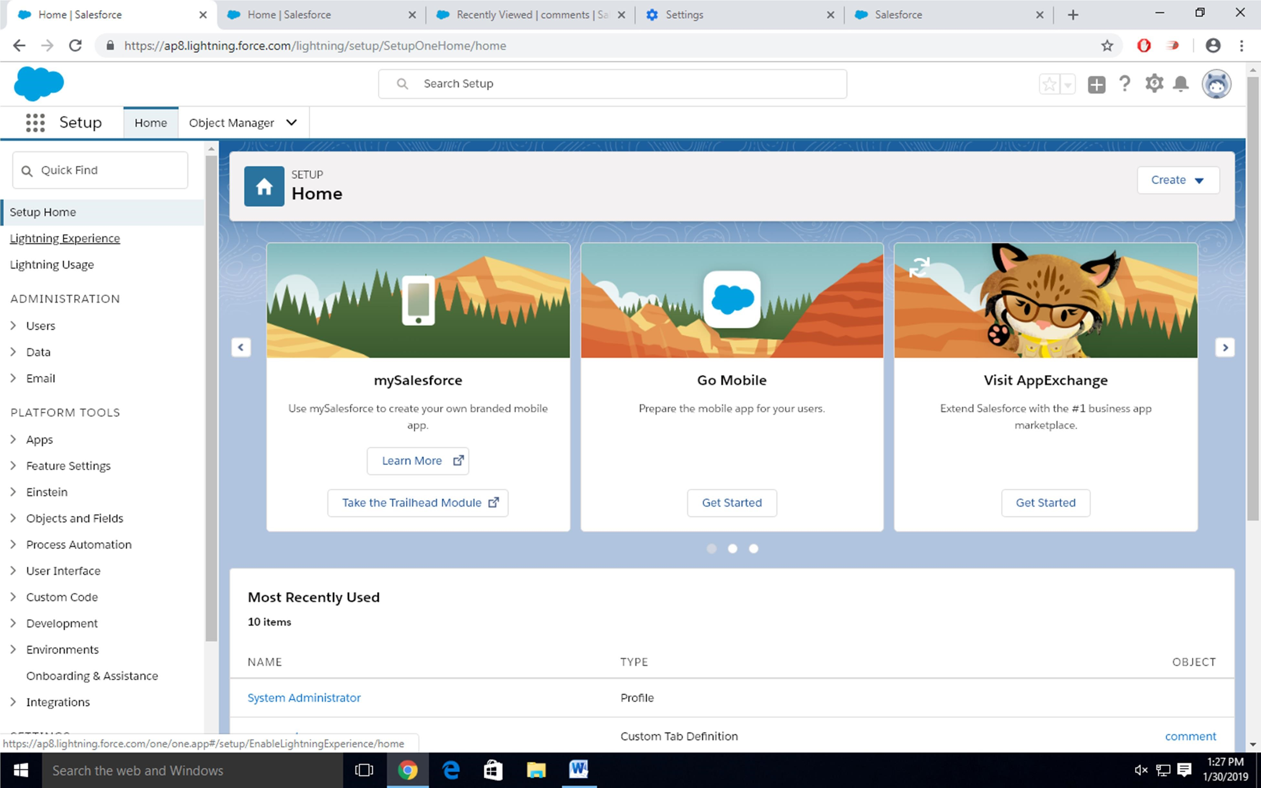

Click on Create an Object

So Click on Object Manager Tab next to Home Tab

Click on Create –Custom Object

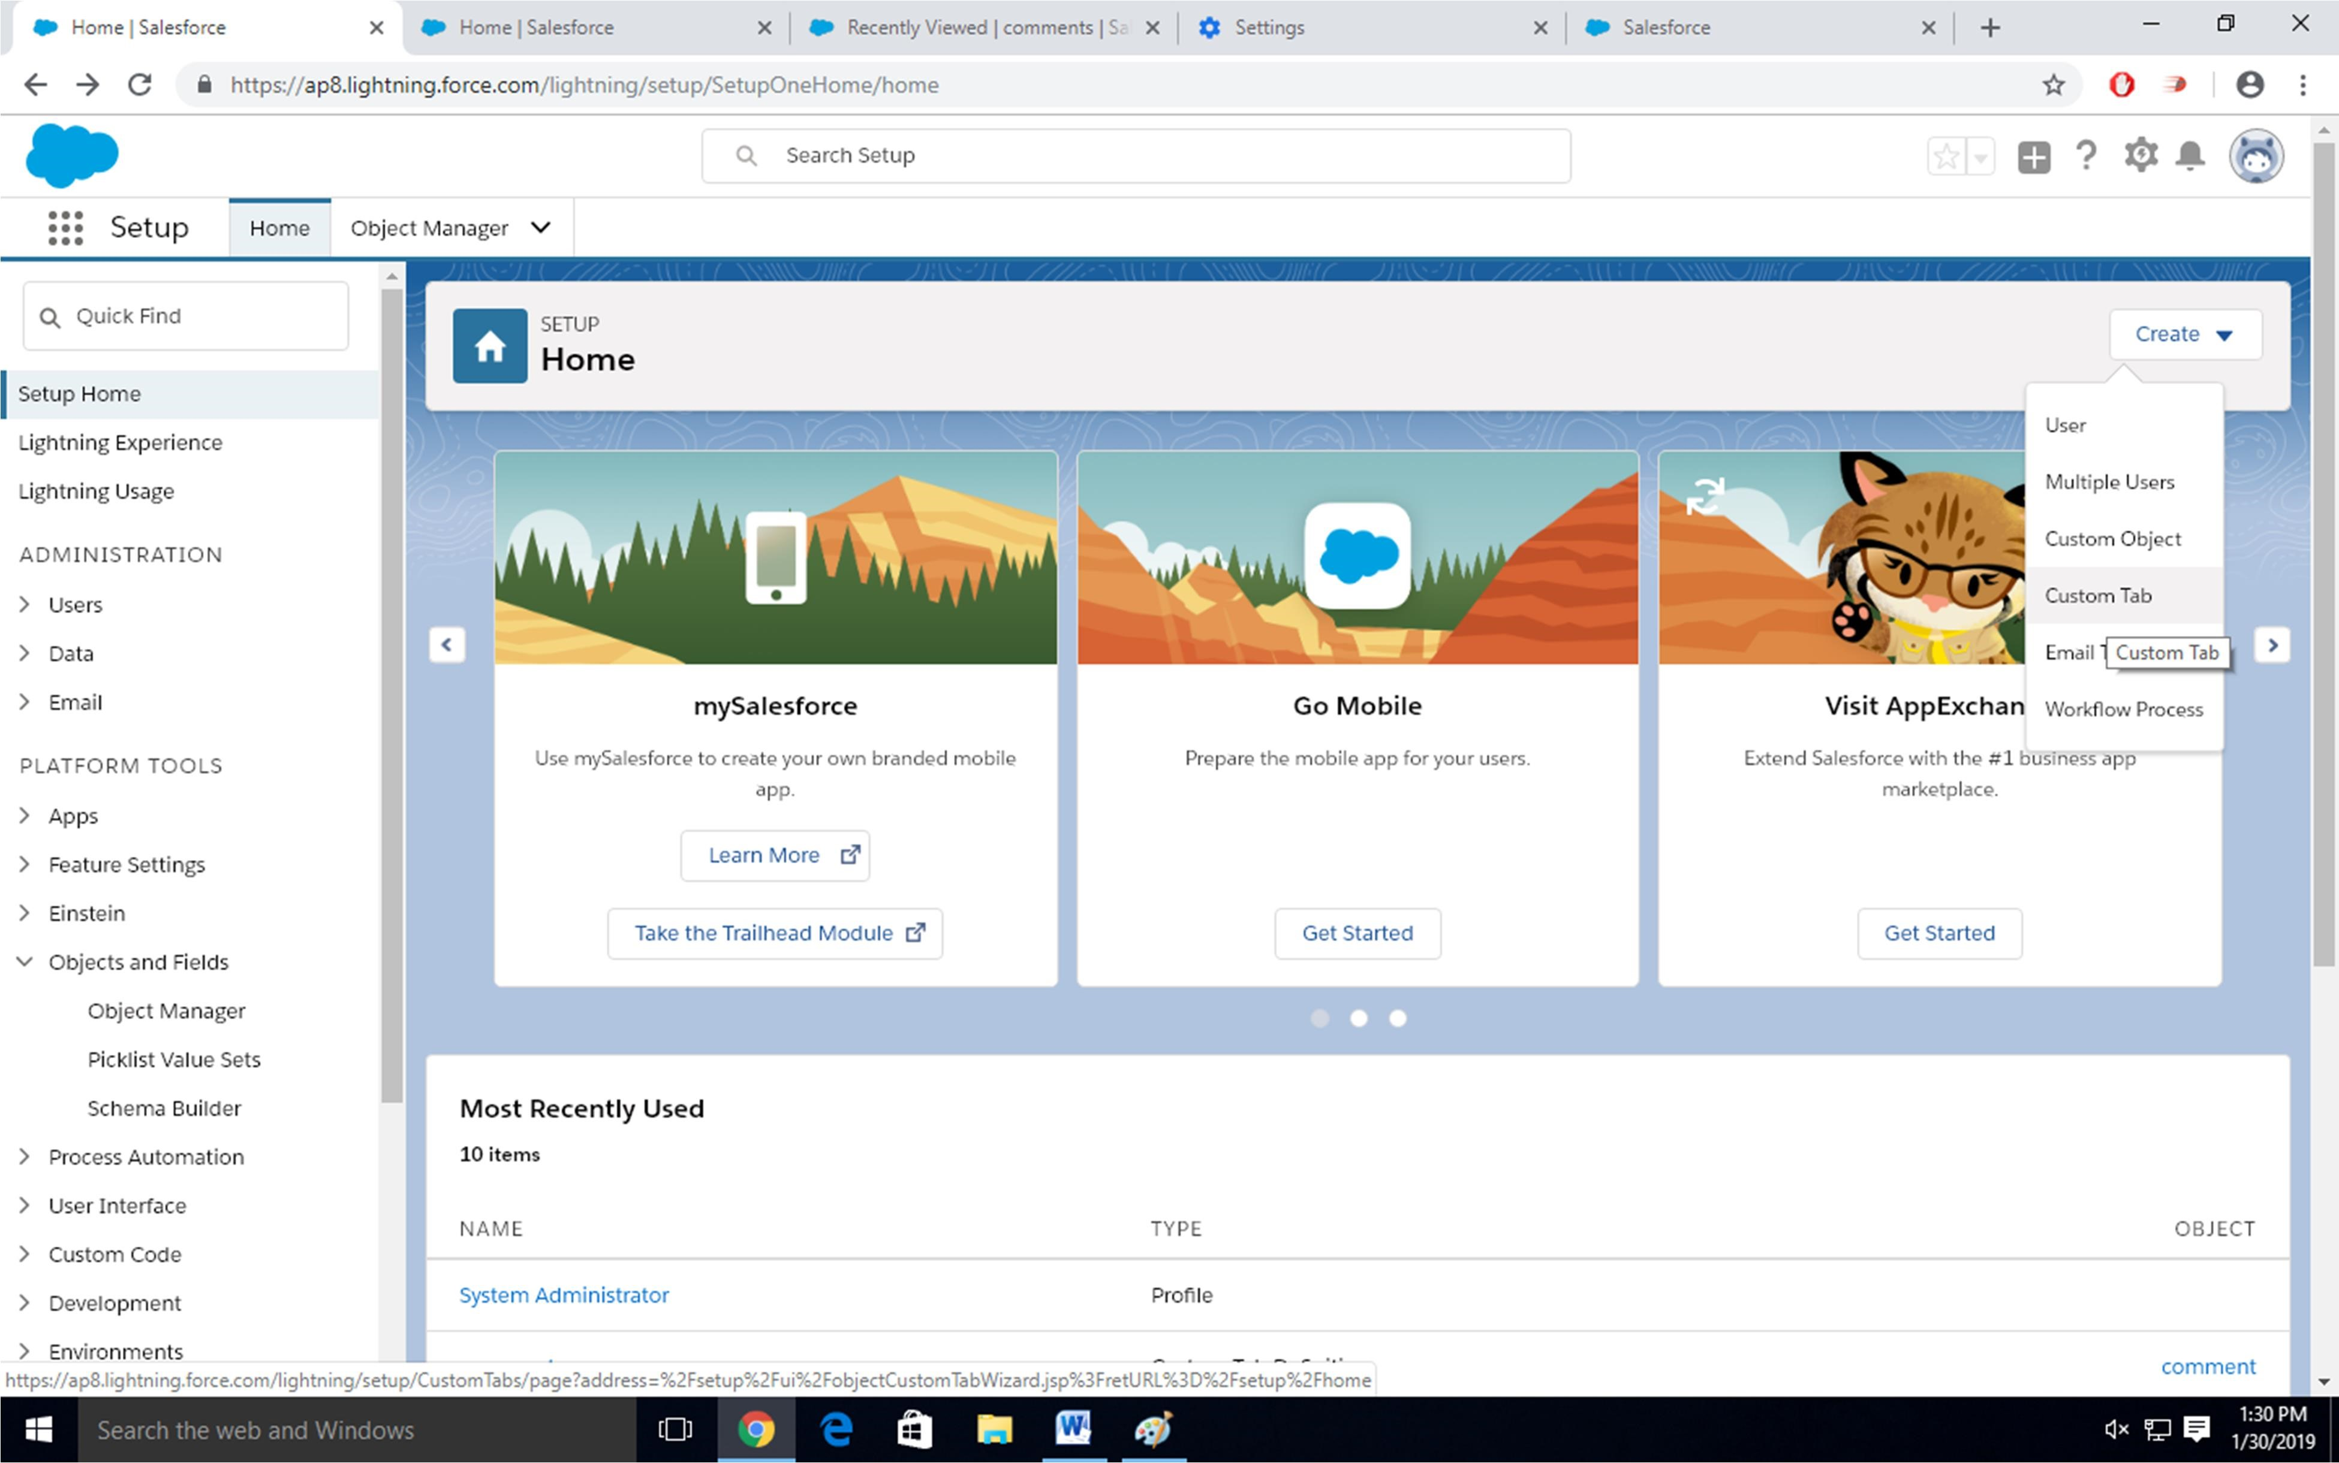

Step-4 New custom object page Open

Label as a-Comment

Plural label- comments

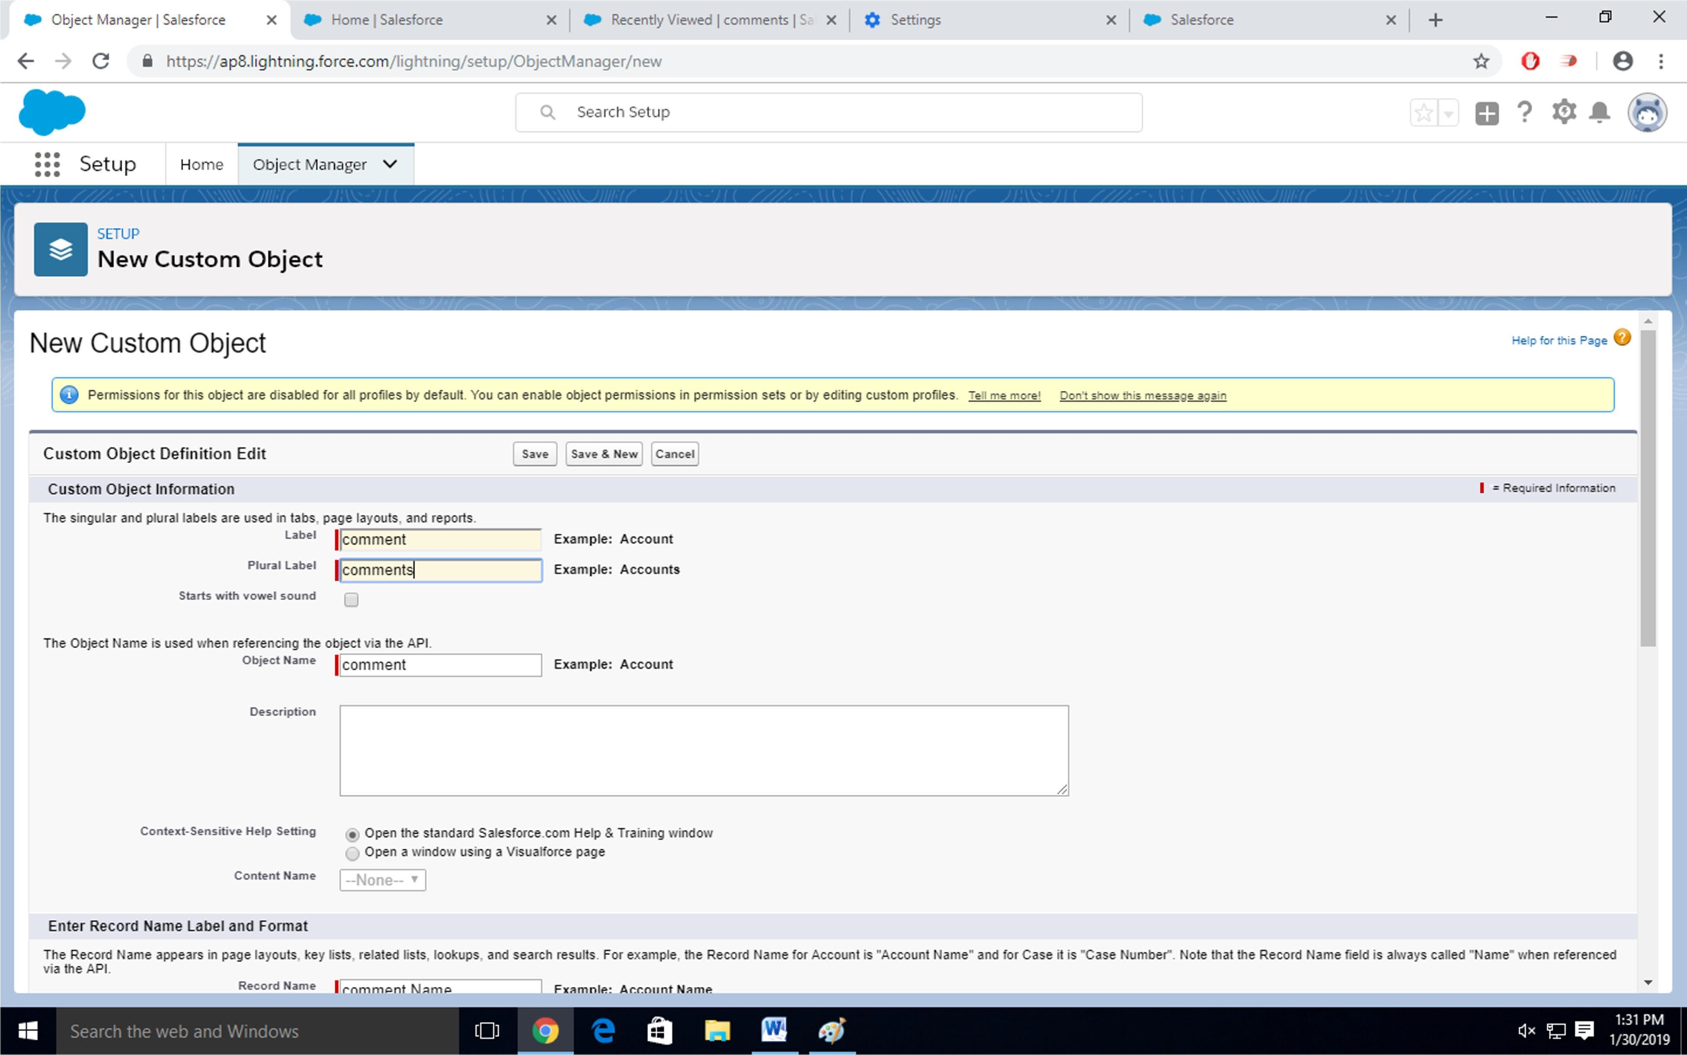

Give Record Name as –comment name

Data type- text

Select Allow Reports Check Box

Click on Save

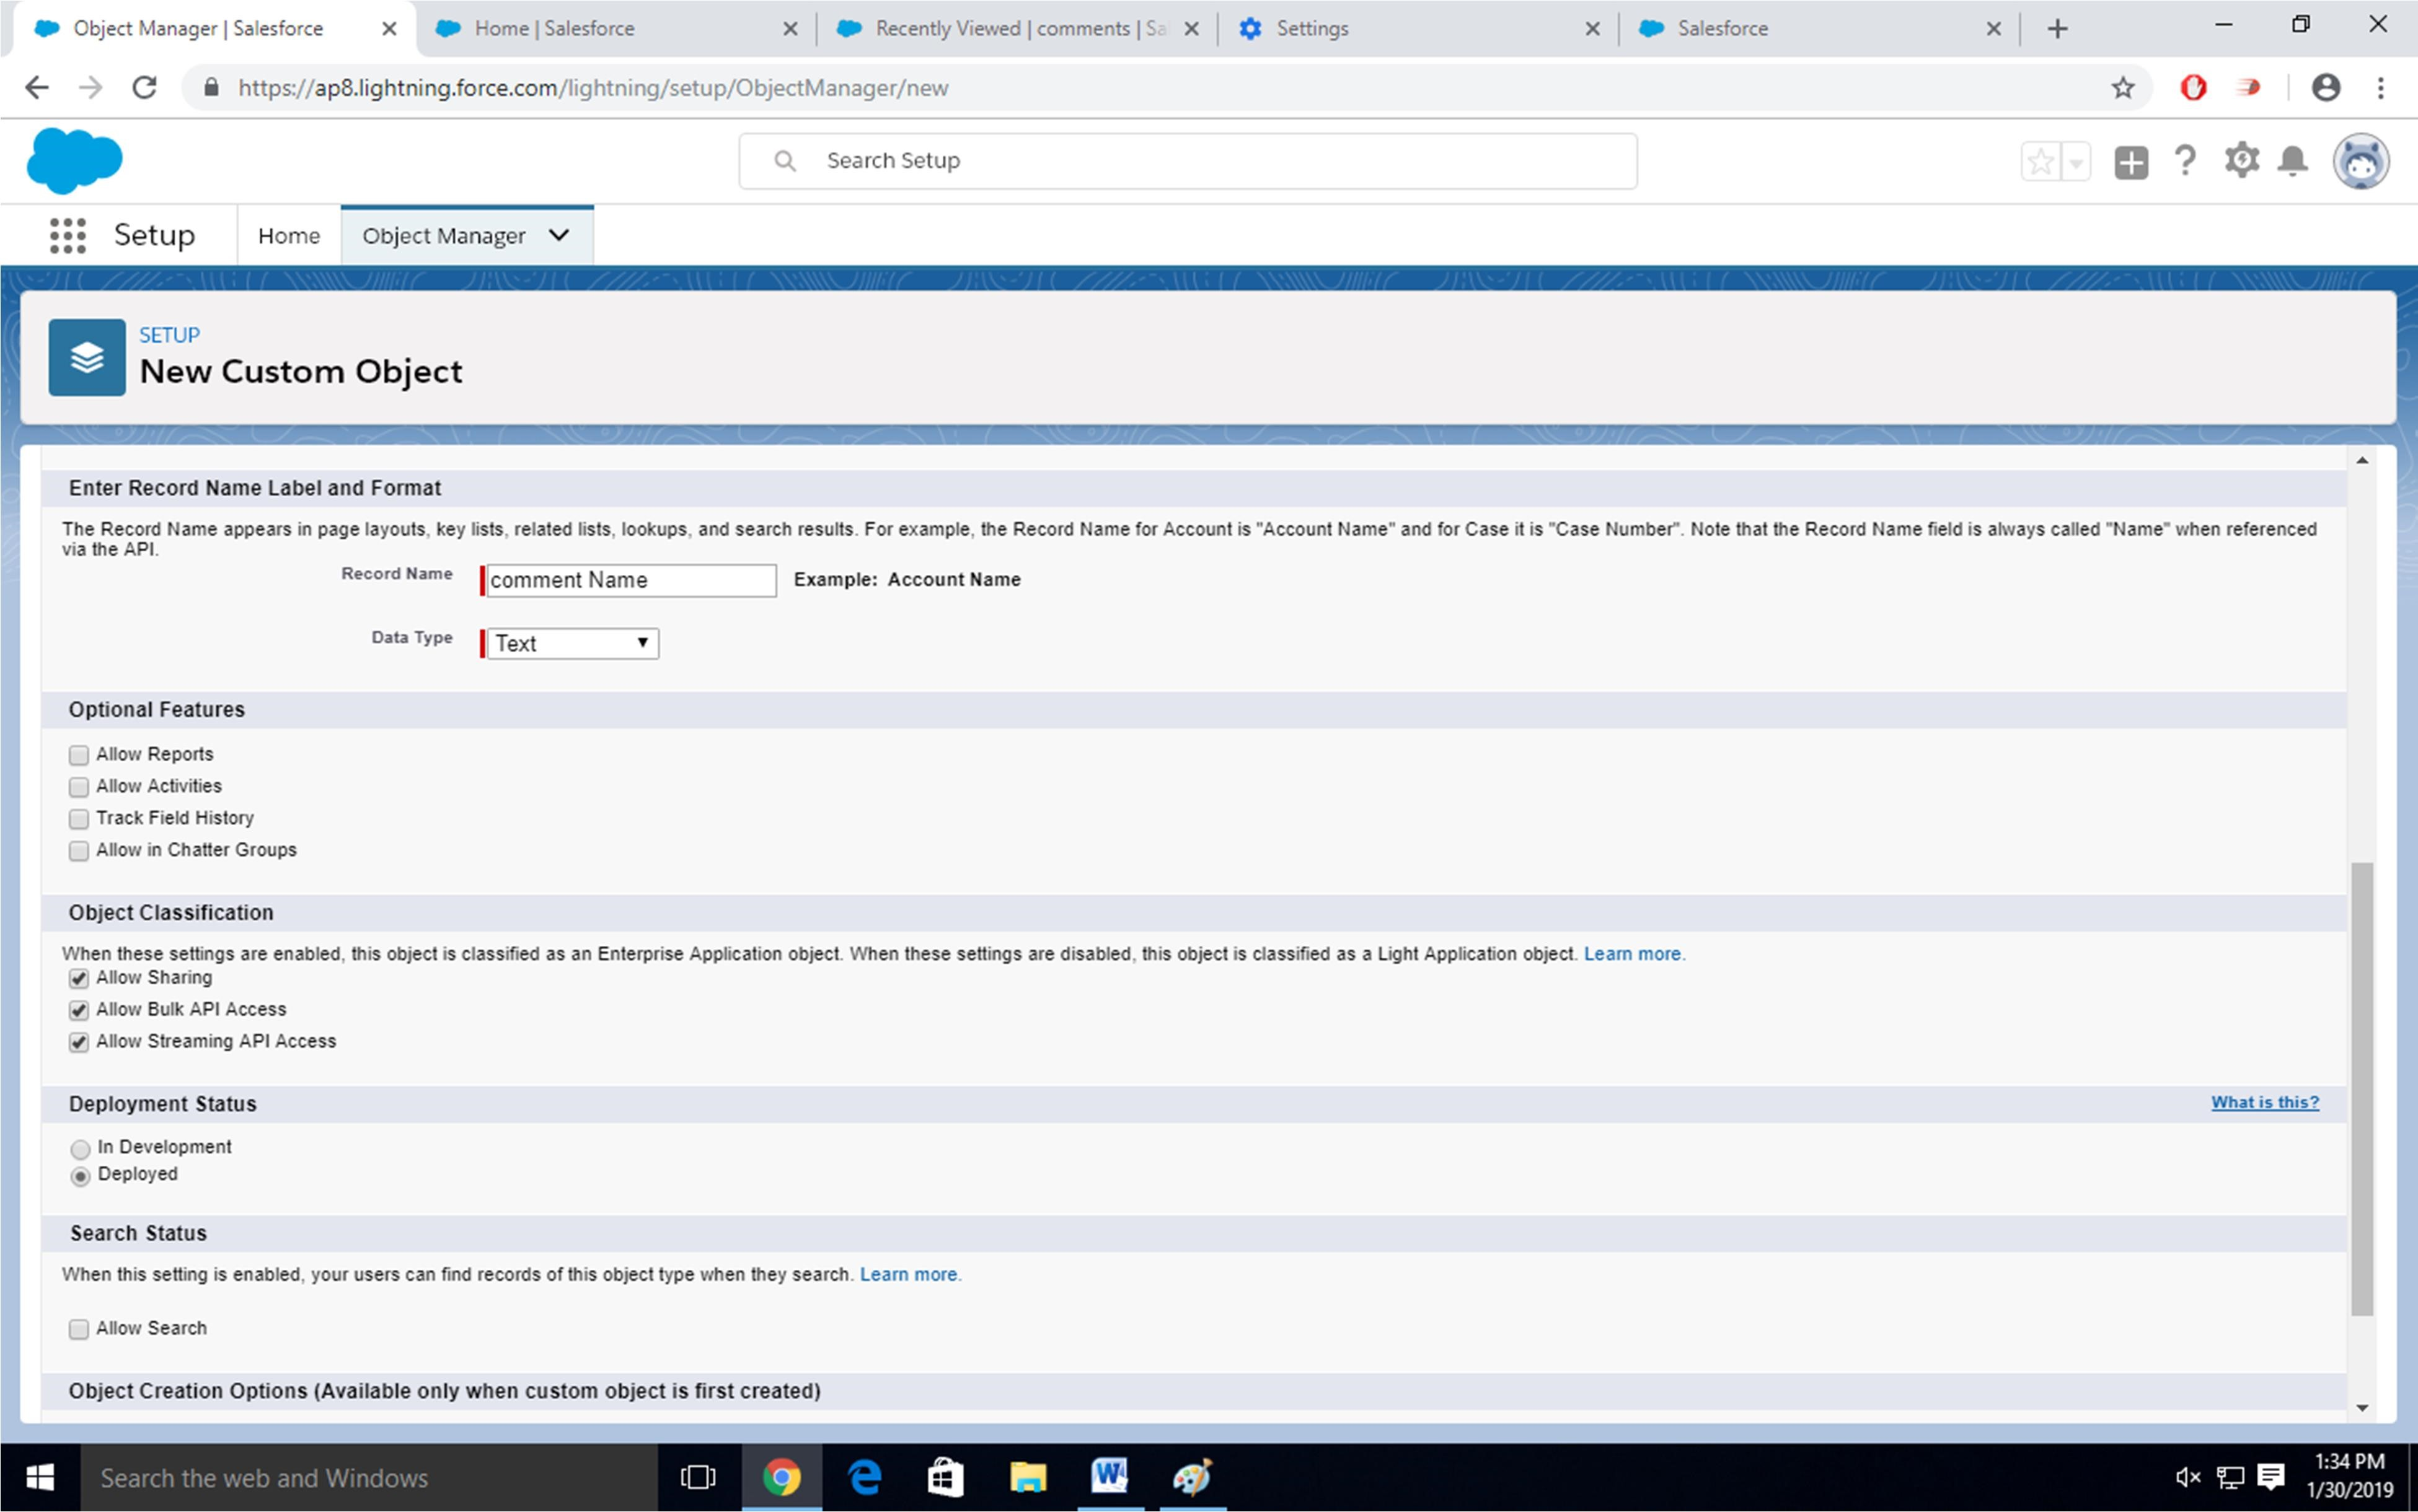

Step-5

Click on Home-Search Tabs in Quick search

Select Custom Object-Click on New

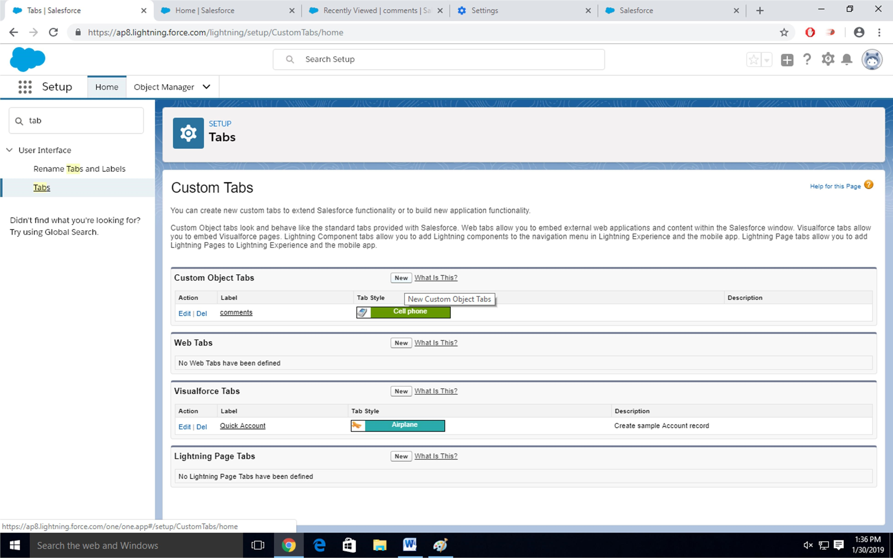

Step-6

For Object Select Comment

For Tab Style Select Any Icon

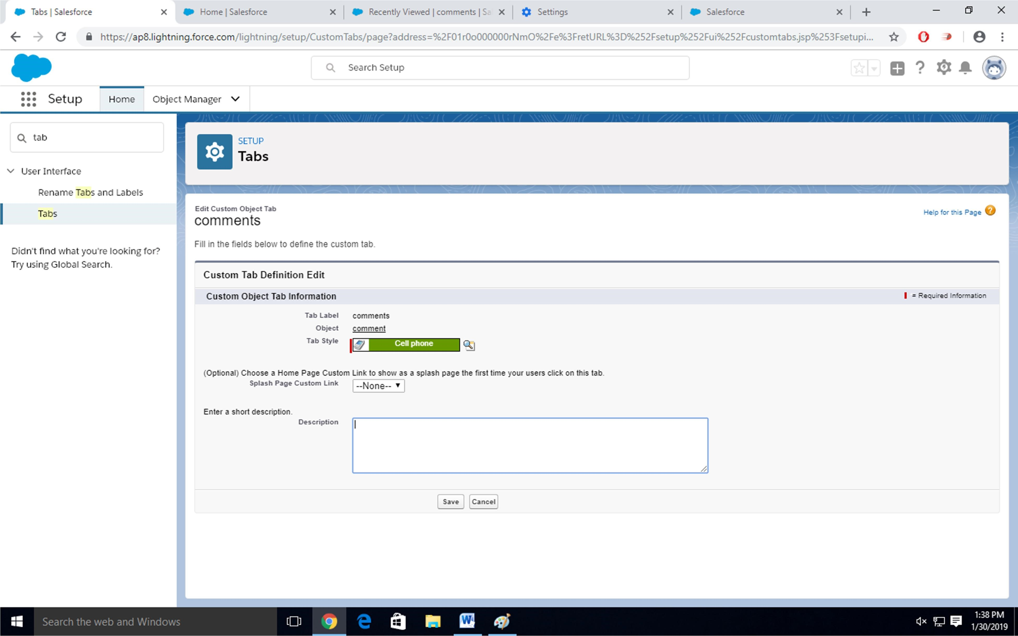

Click-Next-Next-Save

Step-7

Search App Manager in Quick Search and select app manager

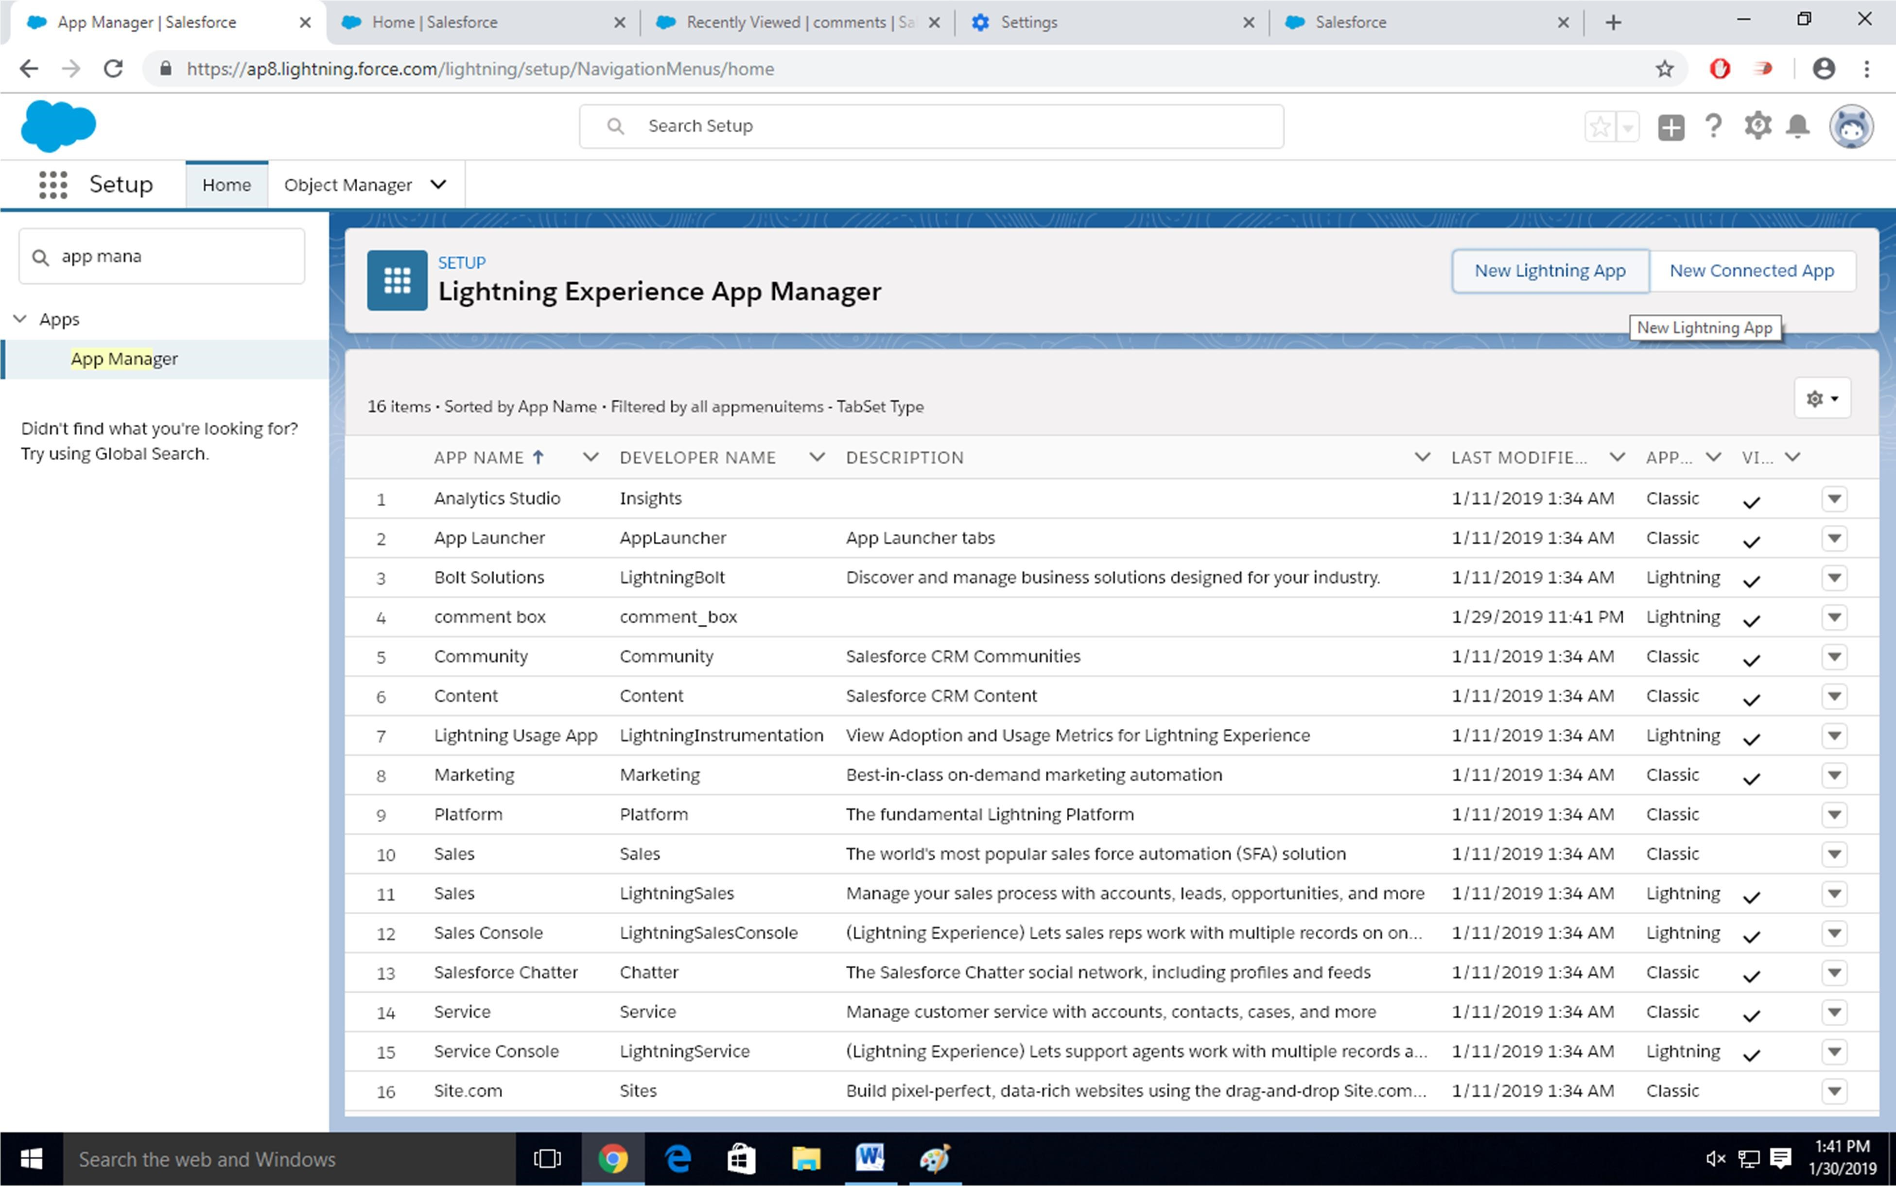

Enter name to app name

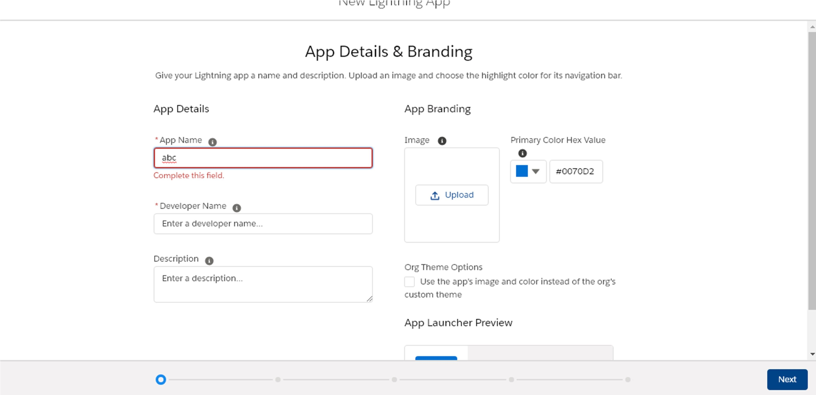

Click on Next-Next-Next.

Select Items (Contacts,Comment)

Click on Next

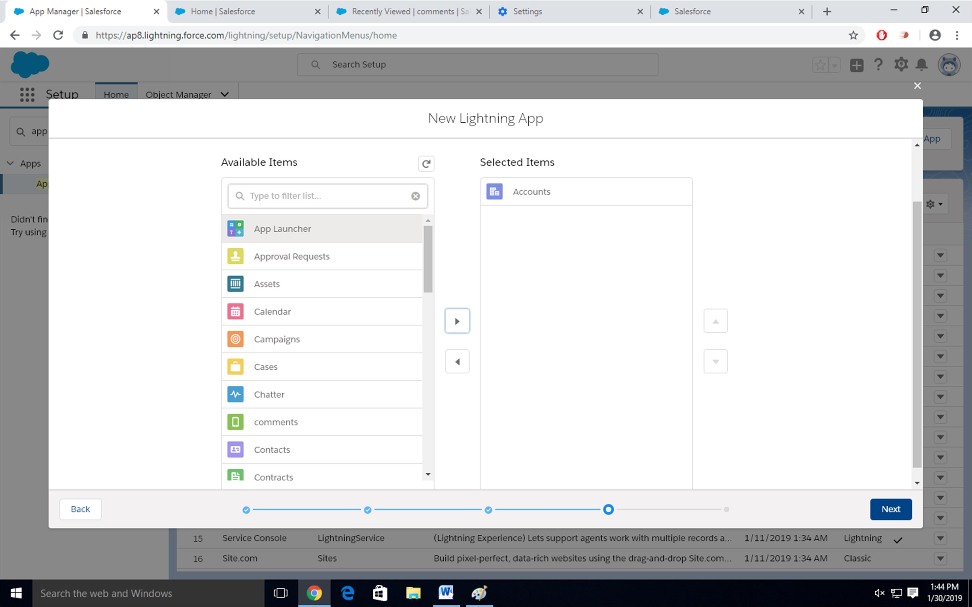

Step-8

Select Profiles ( System Administrator) and move to selected profile.

Click on Save and Finish.

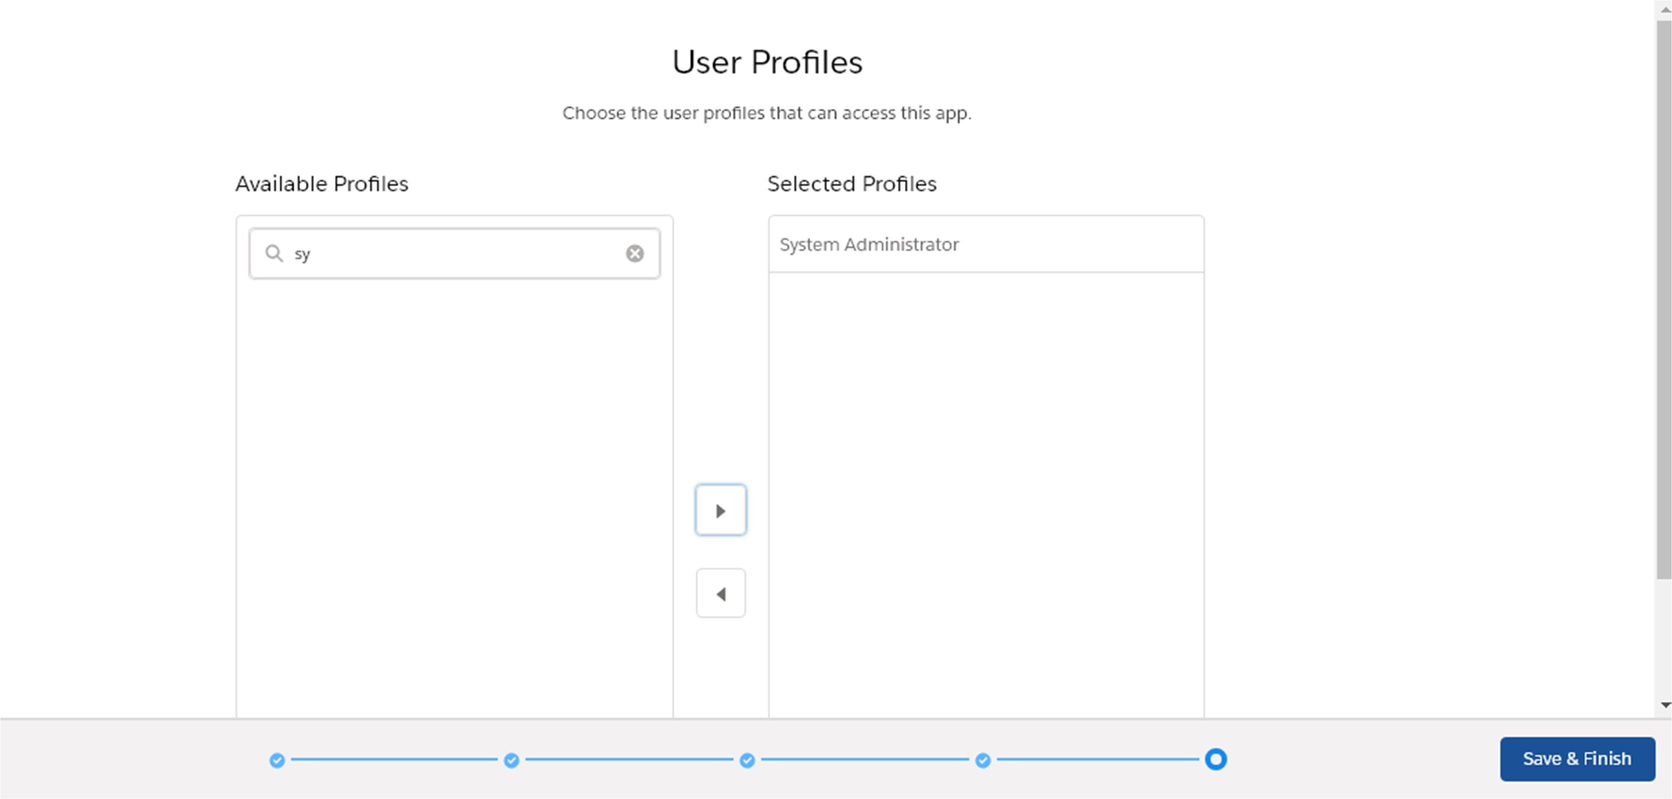

Step-9

Click on App Launcher 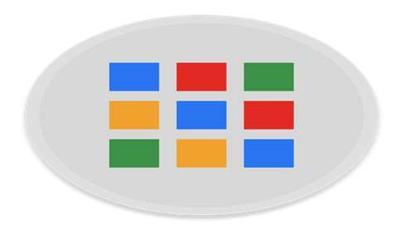 Symbol and Select Comment Box App

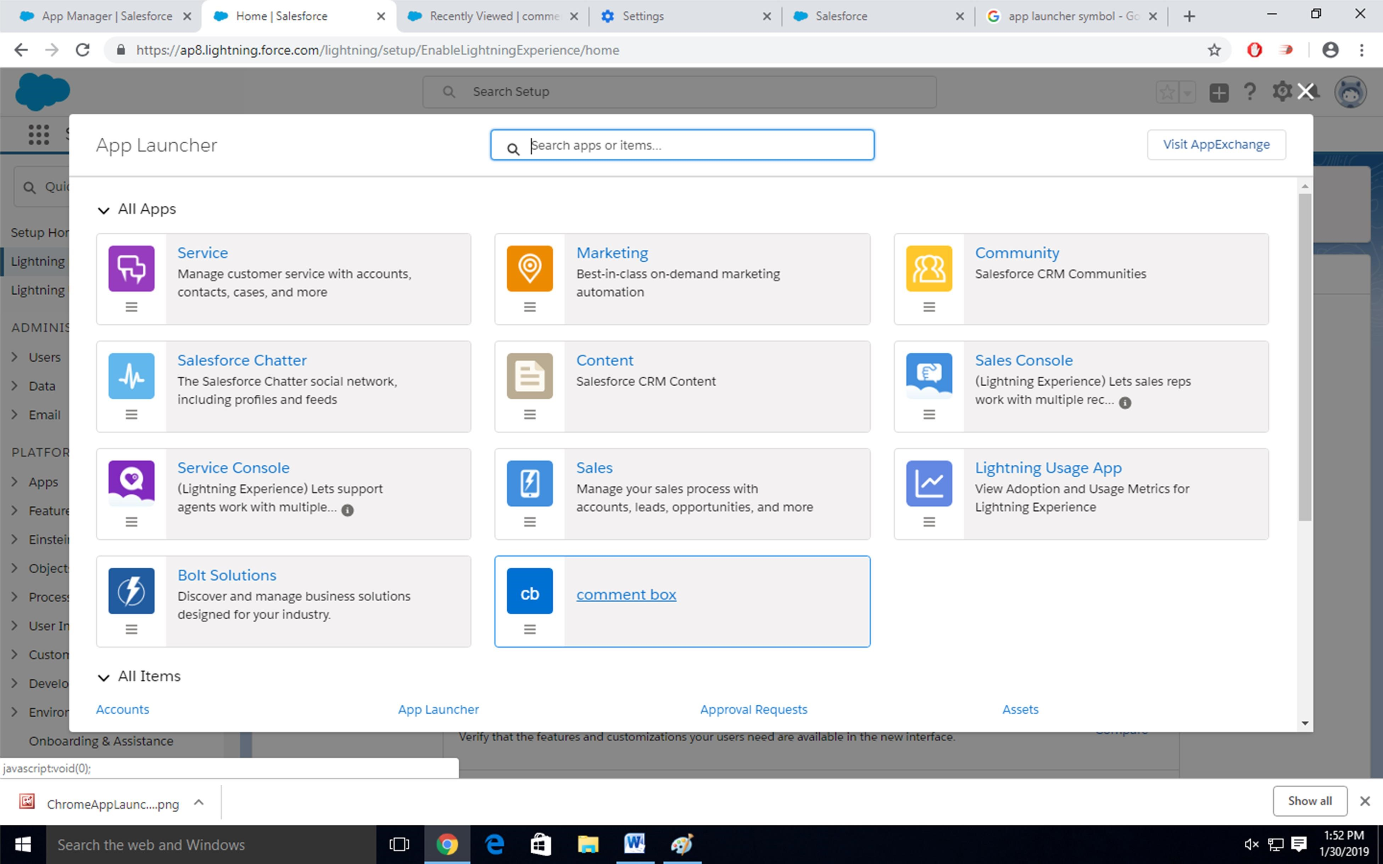

Step-11

Tour the app

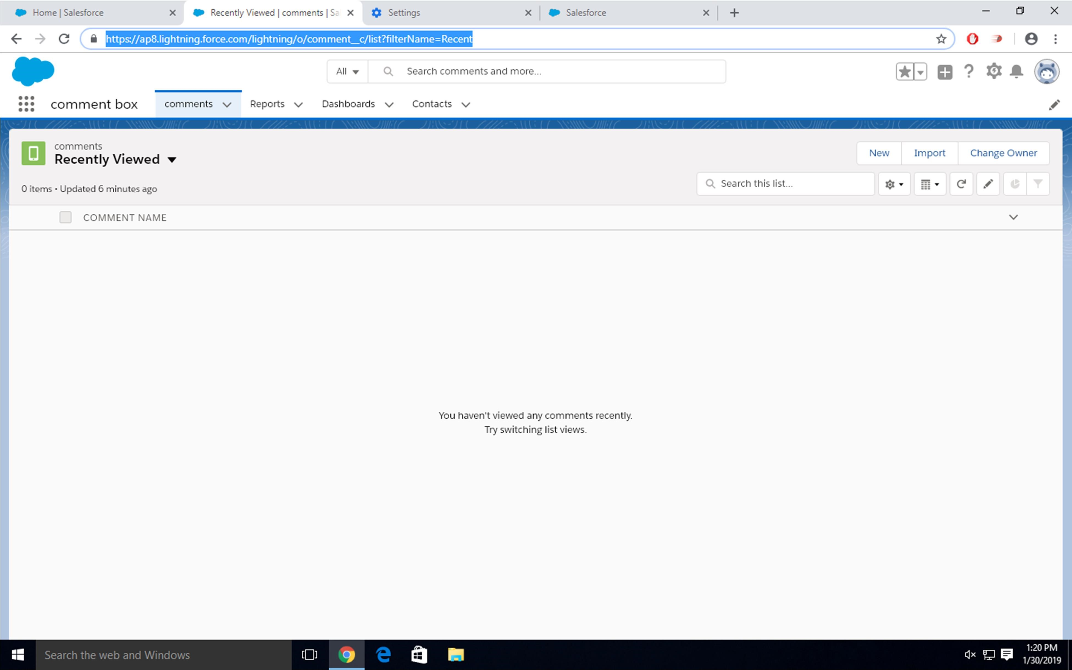

Step-12

Try out mobile app

-Select Chrome developer tools

-Open Chrome-Right Click on Chrome page- Select Inspect

-Click Toggle Device Mode Button to simulate your browser as a mobile device

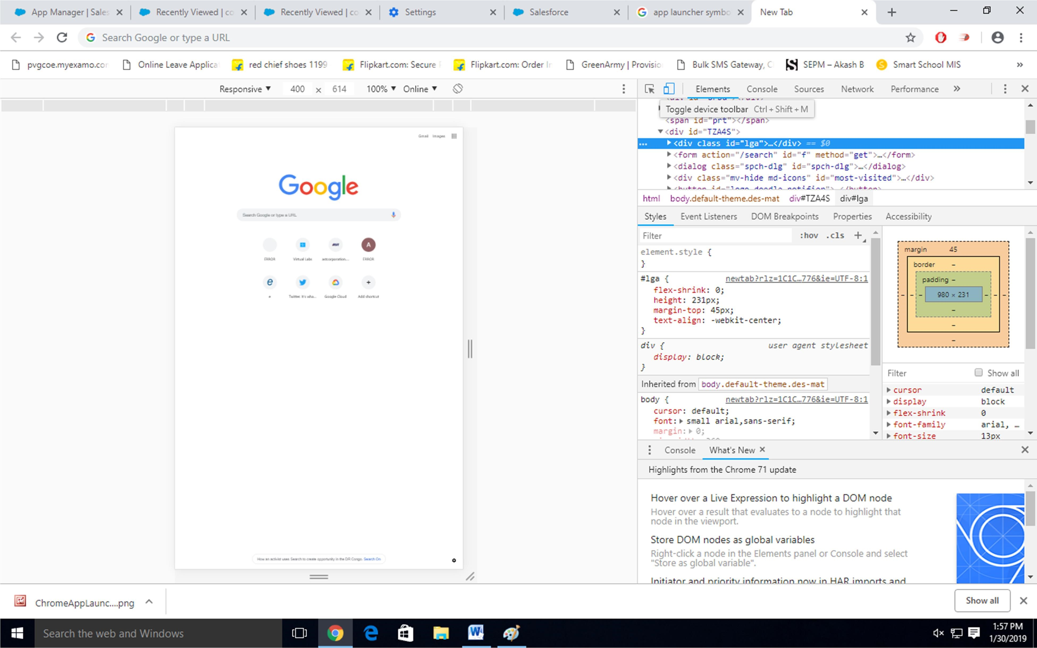

Step-13

To simulate the sales force mobile app in your browser, copy and paste in url from previous tab.Delete the part of the url immediately.

-Click on Left navigation bar

-Find comment object under recent and click on it

-Click new to create a comment

